Life Cycle Plan (LCP)

Transportation Grant Fund Database

Team 14

KarimSacre – Project Manager
Ayman Khalil – Operational Concept Engineer
Kirill Khistayev – System Architect
Stephen Rice – IIV&V
Darren Liu – Tester
ZhannaSeitenova – Lifecycle Planner

April 26, 2012

Version History
Date | Author | Version | Changes made | Rationale
09/17/11 | ZS | 1.0 | Original template.  Filled out roles and responsibilities | Initial draft v1.0
09/22/11 | ZS | 1.1 | Updated sections 1.3, 2.1, 2.2.1, 4.2  Deleted empty tables/rows | Applied the changes described in bugs # 4476 and 4480
09/26/11 | ZS | 1.1 | Updated section 3.1, 2.1, 2.2.1 | Bug #4481 resolution and shifted assignments’ schedule
10/02/11 | ZS | 1.1 | Removed Initial prototype from Table 1. | According to class website Prototype comes as part of Core FCP.
10/07/11 | ZS | 2.0 | Added info to comply with the minimum exit criteria for LCP within Core FCP | FCR
10/13/11 | ZS | 2.1 | Edited section 4.1.1 | Bug 4862
10/19/11 | ZS | 2.2 | Added Project Estimations. Section 5 | FCR ARB
10/23/11 | ZS | 2.3 | Changed roles and skillsfor the next semester | FCR ARB comments
11/12/11 | ZS | 2.3 | Renamed document | Draft DCR
11/15/11 | ZS | 3.0 | Incorporated TA’s comments from FCP evaluation | Draft DCR
11/30/11 | RM | 3.1 | Added introduction for 2.1, 3.0, 4.0 sections, Updated Tables 5, 10 | Bug fixing (6536, 6512, 6269, 6267)
12/04/11 | KK | 3.2 | section 2.1, 2.2.5 changed | DCR ARB Comments
12/12/11 | RM | 3.3 | Section 3.2 and 5 modified | DCP review comments
2/2/12 | ZS | 4.0 | Changed name, version, status, Cotipmo estimation of the document. Added section 6 | Draft RDCR
3/26/12 | ZS | 5.0 | Changed name, version, status.  Edited section 6.2 | IOC1
4/2/12 | ZS | 5.1 | Added sections 6.2.1, 6.2.2 and 6.3 | CCD Report
4/15/12 | ZS | 5.1 | Fixed headers | Bug # 6976
4/15/12 | ZS | 5.2 | Updated sections 5 and 6.2 | TS Set
4/26/12 | ZS | 5.3 | Updated sections 1.2, 5, 6.2 and 6.3 | IOC3

Table of Contents
Life Cycle Plan (LCP) i
Version History ii
Table of Contents iii
Table of Tables iv
Table of Figures v
1. Introduction 1
1.1 Purpose of the LCP 1
1.2 Status of the LCP 1
1.3 Assumptions 1
2. Milestones and Products 2
2.1 Overall Strategy 2
2.2 Project Deliverables 4
3. Responsibilities 8
3.1 Project-specific stakeholder’s responsibilities 8
3.2 Responsibilities by Phase 9
3.3 Skills 11
4. Approach 15
4.1 Monitoring and Control 15
4.2 Methods, Tools and Facilities 15
5. Resources 17
6. Iteration Plan 20
6.1 Plan 20
6.2 Iteration Assessment 22
6.3 Adherence to Plan 24

Table of Tables
Table 1: Artifact deliverable in Exploration Phase 4
Table 2: Artifact deliverable in Valuation Phase 4
Table 3: Artifact deliverable in Foundations Phase 5
Table 4: Artifact deliverable in Rebaselined Development Phase 6
Table 5: Artifact deliverable in Development Phase – Construction iteration 6
Table 6: Artifact deliverable in Development Phase – Transition iteration 7
Table 7: Business side Stakeholders’ Roles and Responsibilities 8
Table 8: Development team’s Responsibilities in each phase 9
Table 9: Development team’s Roles and Skills for 577a 11
Table 10: Development team’s Roles and Skills for 577b 13
Table 11: Tools to be used in the project 15
Table 12: COCOMOII Cost Driver 17
Table 13: Construction iteration capabilities to be implemented 20
Table 14: Construction iteration capabilities to be tested 21
Table 15: Construction iteration capabilities implemented and tested 22
Table 16: Construction iteration capabilities implemented and tested in 2 iterations 23

Table of Figures
Figure1: Process Decision Graph 2
Figure2: COTIPMOProject Estimates 18

    - Introduction

Purpose of the LCP
The purpose of the life cycle plan is to identify the project delivery approach, project’s milestones and products, as well as identify implementation team’s roles and responsibilities. This plan will help control and realize the win-win conditions for all stakeholders, and detect risks that may become an obstacle for the success of the project.

Status of the LCP
This version of the Life Cycle Plan is the result of the Development phase, and is a product within the IOC3 Package. Since, a postponed schedule is not a choice for the project, this version of the plan served to set important deadlines for the Valuation, Foundations and Development phases, as well as to clarify the team members’ responsibilities as the project progresses.

Assumptions
- The total duration of the project is 24 weeks. This time is split between two semesters, 12 weeks long each.
  - Each member of the team, including clients and other success-critical stakeholders, are well aware of their responsibilities, and will carry them out throughout the projects.
  - The developers, clients, and stakeholders will be in constant communication with one another.
  - The clients will not drastically change the measure of the project within the semester, even though they have future aspirations concerning the system.
  - The client will provide a deployment and testing environment.
  - The client constrains the development team to build new system using Microsoft Sharepoint (PM Central in particular).

    - Milestones and Products

Overall Strategy
The Transportation Grant Fund Database system will be build usingNDI Intensive process. Figure 1 illustrates the Decision Graph, which has only one non-conforming point. During the development process, the project team will follow the Incremental Commitment Spiral Model. As a platform for the future system team will use PM Central (MicrosoftSharepoint) product. Project work will be divided into several increments. The first and foremost task is to identify client’s requirements and classify them with different priorities. Those that are classified as “must-have” requirements (system’s core capabilities) are to be considered in the first increment. Requirements with low priorities will be considered in the following increments if given enough time and resources.
Figure1: Process Decision Graph
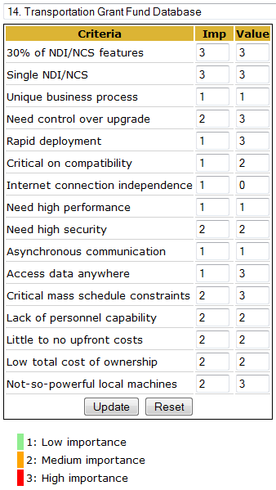
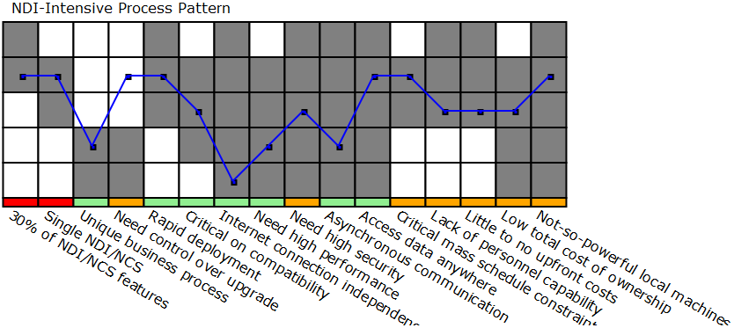

Exploration phase
Duration: 9/12/11- 9/28/11
Concept: During the Exploration phase, the team will be introduced to their clients, and set up several meetings in order to learn “as-is” business process, new system’s initial requirements, also to detect risks and decisions that need to be made and have already been addressed by some of the stakeholders. The team will plan the time they have and the project’s deliverables in order to assure that the project will be released on time.
Deliverables: Valuation Commitment Package
Milestone: Valuation Commitment Review
Strategy: One Incremental Commitment Cycle

Valuation phase
Duration: 9/29/11- 10/24/11
Concept: During the Valuation Phase, the development team will elaborate on the new system’s requirements. As each of the requirements is being realized in the prototype, the issues that come up will need to be addressed. All stakeholders will be involved in finding possible options as solutions for the issues that may arise.
Deliverables: Foundations Commitment Package
Milestone: Foundations Commitment Review
Strategy: Win-win negotiation, initial prototype development

Foundations phase
Duration: 10/25/11- 12/5/11
Concept: Using complete set of system requirements, the project team must spend most of their effort in creating a fully functioning prototype of the system. If any issues arise, it is to be discussed with all of the success-critical stakeholders. Test and transition plans should be prepared.
Deliverables: Development Commitment Package
Milestone: Development Commitment Review
Strategy: Mostly prototype development, with necessary meetings

Rebaselined Foundations phase
Duration: 1/9/12- 2/1/12
Concept: The prototype is rebaselined and CSCI 577b specifics are planned including the key risk items and transition strategies. Knowledge is to be shared and transferred to newly joined team members.
Deliverables: Rebaselined Development Commitment Package
Milestone: Rebaselined Development Commitment Review
Strategy: Mostly review, reassessment, with necessary meetings

Development (construction iteration) phase
Duration: 2/1/12- 4/2/12
Concept: development team needs to implement the system prototyped during the first half of the life cycle. Most, if not all issues and risks should be resolved or have plans for being controlled. The implemented system should be tested and ready for transition.
Deliverables: Working system, Operation Commitment Package, SharePoint project package (Site collections/Templates)
Milestone: Core Capability Drive-through
Strategy: Mostly implementation, with necessary meetings

Development (transition iteration) phase
Duration: 4/3/12- 5/4/12
Concept: The system should be transitioned and installed, so that the clients and users of the system are able to successfully use it. Training should be offered and given to most of the clients and users if necessary, so that at least a good number of people know exactly how to use the system and can train the other clients and users.
Deliverables: Transition package, Operation Commitment Package, SharePoint project package (Site collections/Templates)
Milestone: Operation Commitment Review
Strategy: Transition, training

Project Deliverables
This section describes all of the artifacts the team is responsible to produce and by when.

Exploration Phase
Table 1: Artifact deliverable in Exploration Phase
Artifact | Due date | Format | Medium
Client Interaction Report | 9/21/2011 | .doc, .pdf | Soft copy
Valuation Commitment Package  - Operational Concept Description (OCD) Early Section  - Life Cycle Plan (LCP) Early Section  - Feasibility Evidence Description (FED) Early Section | 09/28/2011 | .doc, .pdf | Soft copy
Progress Report | Every Wednesday | .xls | Soft copy
Project Plan | Every Wednesday | .mpp | Soft copy

Valuation Phase
Table 2: Artifact deliverable in Valuation Phase
Artifact | Due date | Format | Medium
Core Foundations Commitment Package  - Operational Concept Description (OCD)  - Life Cycle Plan (LCP)  - Feasibility Evidence Description (FED)  - Prototype (PRO)  - System and Software Architecture Description (SSAD)  - Win Conditions Prioritization  - Supporting Information Document (SID) | 10/07/2011 | .doc, .pdf | Soft Copy
Draft Foundations Commitment Package  - Operational Concept Description (OCD)  - Life Cycle Plan (LCP)  - Feasibility Evidence Description (FED)  - Prototype (PRO)  - System and Software Architecture Description (SSAD)  - Win Conditions Prioritization  - Supporting Information Document (SID) | 10/14/2011 | .doc, .pdf | Soft Copy
Foundations Commitment Package  - Operational Concept Description (OCD)  - Life Cycle Plan (LCP)  - Feasibility Evidence Description (FED)  - Prototype (PRO)  - System and Software Architecture Description (SSAD)  - Win Conditions Prioritization  - Supporting Information Document (SID)  - Quality Management Plan (QMP) | 10/24/2011 | .doc, .pdf | Soft copy
Progress Report | Every Wednesday | .xls | Soft copy
Project Plan | Every Wednesday | .mpp | Soft copy

Foundations Phase
Table 3: Artifact deliverable in Foundations Phase
Artifact | Due date | Format | Medium
Draft Development Commitment Package  - Operational Concept Description (OCD)  - Life Cycle Plan (LCP)  - Feasibility Evidence Description (FED)  - Prototype (PRO)  - System and Software Architecture Description (SSAD)  - Win Conditions Prioritization  - Supporting Information Document (SID)  - Quality Management Plan  - Test Plan (TP)  - Iteration Plan (IP)  - Acceptance Test Plan (ATP) | 11/21/2011 | .doc, .pdf | Soft Copy
Development Commitment Package  - Operational Concept Description (OCD)  - Life Cycle Plan (LCP)  - Feasibility Evidence Description (FED)  - Prototype (PRO)  - System and Software Architecture Description (SSAD)  - Win Conditions Prioritization  - Supporting Information Document (SID)  - Quality Management Plan  - Test Plan (TP)  - Iteration Plan (IP)  - Acceptance Test Plan and Cases(ATPC) | 12/05/2011 | .doc, .pdf | Soft Copy
Project Archive | 12/12/2011 | link | Soft Copy
Progress Report | Every Wednesday | .xls | Soft copy
Project Plan | Every Wednesday | .mpp | Soft copy

Rebaselined Development Phase
Table 4: Artifact deliverable in Rebaselined Development Phase
Artifact | Due date | Format | Medium
Rebaselined Development Commitment Package  - Operational Concept Description (OCD)  - Life Cycle Plan (LCP)  - Feasibility Evidence Description (FED)  - System and Software Architecture Description (SSAD)  - Win Conditions Prioritization (WWPT)  - Supporting Information Document (SID)  - Quality Management Plan (QMP)  - Transition Plan (TP)  - Test Plan and Cases (TPC)  - UML | 02/15/2012 | .doc, .pdf | Soft Copy
Progress Report | Every Wednesday | .xls | Soft copy
Project Plan | Every Wednesday | .mpp | Soft copy

Development Phase
Table 5: Artifact deliverable in Development Phase – Construction iteration
Artifact | Due date | Format | Medium
Initial Operational Capability Package:  - Operational Concept Description (OCD)  - Life Cycle Plan (LCP)  - Feasibility Evidence Description (FED)  - System and Software Architecture Description (SSAD)  - Win Conditions Prioritization (WWPT)  - Supporting Information Document (SID)  - Quality Management Plan (QMP)  - Test Plan and Cases (TPC)  - Test Procedure and Results (TPR)  - UML  - Iteration Assessment Report | 03/26/2012 | .doc, .pdf | Soft copy
Core Capability Drive-Thru Report | 04/02/2012 | .doc, .pdf | Soft Copy
Progress Report | Every Wednesday | .xls | Soft copy
Project Plan | Every Wednesday | .mpp | Soft copy
SharePoint project package (Site collections/Templates) | At the end of every construction iteration | .zip | Soft Copy
Table 6: Artifact deliverable in Development Phase – Transition iteration
Artifact | Due date | Format | Medium
Transition Readiness Review Package  - Transition Plan (TP)  - User Manual (UM)  - Support Plan (SP)  - Training Materials (TM)  - Regression Test Package (RTP) | 04/09/2012 | .doc, .pdf | Soft Copy
Support and Transition Set Package | 04/16/2012 | .doc, .pdf | Soft Copy
Close Out Report | 05/04/2012 | .doc, .pdf | Soft Copy
Project Archive | 05/04/2012 | .zip | Soft Copy
Progress Report | Every Wednesday | .xls | Soft copy
Project Plan | Every Wednesday | .mpp | Soft copy

    - Responsibilities
This section briefs the roles and responsibilities of the project’s stakeholders, which include the implementation team and the clients. The phase wise responsibilities expected from each project team member are documented. The skill set required for each team member is also addressed.

Project-specific stakeholder’s responsibilities
All success critical stakeholders are responsible to participate in the WinWin negotiation, weekly meeting, and commitment review, collaborating on the project’s risk issues and performing assigned tasks, as well as to commit to the project progress.

There are several success-critical stakeholders from the business side. Following table describes their roles and responsibilities.
Table 7: Business side Stakeholders’ Roles and Responsibilities
Roles | Responsibilities
System users – The Grants Management Section, Project Managers, Program Managers, LADOT Systems, and LADOT Accounting, LADOT Management, City Management, City Policy Makers, and the General Public. | - Explain current business workflow and context  - Express interests or win conditions  - Provide project-related information and feedback  - Review and test prototypes and the product and provide feedback as appropriate  - Test and deploy the product in operational environment
Client – Mr. William Halverson, LADOT Financial Management Section. | - Prepare for site visit, provide support and collaboration to the development team  - Articulate win conditions and operation concept  - Track system progress  - Coordinate with user, maintainer and developer  - Provide information and feedback, review and test the product  - Test and deploy the product in operational environment  - Support system’s transition  - Receive training for the new system, provide training for regular users
System maintainer – Mr. Mony Patel, DBA | - Express interests or win conditions  - Provide information and show current system environment  - Provide information and feedback, review and test the product  - Prepare test and operational environment  - Test and deploy the product in operational environment  - Receive training for the new system, provide training for users  - Maintain the system

The client and new system users overlap widely, and are responsible for meeting with the development team on a regular basis in order to develop system requirements, assess and mitigate risks and issues, make decisions relevant to resolving risks and issues, and give their feedback on the work done by the development team.

Development team’s roles and responsibilities are described in the next section.

Responsibilities by Phase
There are 7 team members working in this project during the two semesters. Their responsibilities in each phase are listed in the following table.
Table 8: Development team’s Responsibilities in each phase
Team Member / Role | Primary / Secondary Responsibility
Team Member / Role | Exploration | Valuation | Foundations | Development- Construction Iteration | Development- Transition Iteration
MurugananthamRaju / Project Manager (PM), Feasibility Analyst (FA) / UML Modeler (UML) | PM: Detail Project Plan, Record Project Progress  FA: Assess and Plan to Mitigate Risks | FA: Explore Alternatives, Provide Project Feasibility Evidence, Acquire NDI or NCS components  PM: Plan and Manage Project  UML: Analyze the Proposed System | PM: Plan and Manage Project  FA: Assess project status  UML:Assess System Architecture
KarimSacre / Prototyper (PT), Requirements Engineer (RE) / Tester (T) / Project Manager (PM) / Feasibility Analyst (FA) /  Builder (B) | Implementation team: Analyze Current System, Identify Responsibilities and Skills, Record Project Individual Effort | PT: Identify Operational Concept and Prototype,Define Operational Concept, Prototyping  RE: Define Operational Concept, Define Architecture | RE: Assess project status | PM: Plan Project Life, Track Progress  B: Develop Glue Code, Integrate Components, Fix Defects,  Tailor Components | PM: Track Progress  B: Transition The System  Implementation team: Provide Training
Ayman Khalil / Operational Concept Engineer (OCE)/ Builder (B) / Trainer (T) | OCE: Analyze Current System | OCE: Identify OC&P, Define Operational Concept, Explore Alternatives, Define Architecture  SA: Define Architecture, Provide Project Feasibility Evidence | OCE: Assess project status  B: Fix New System’s Defects | T: Prepare Training Plan, Provide Training  B: Develop Glue Code, Integrate Components, Fix Defects,  Tailor Components | B: Transition The System  T: Provide Training
Kirill Khistayev / System Architect (SA), UML Modeler (UML) / Builder (B) | PM: Detail Project Plan, Record Project Progress  NDIA: Acquire NDI or NCS components | SA: Define Architecture, Provide Project Feasibility Evidence  PM: Plan and Manage Project  NDIA: Assess and evaluate NDI and NCS components Candidates | PM: Plan and Manage Project  T: Identify Test Plan, Identify Test Procedures, Perform Testing, Record Test Results | B: Develop Glue Code, Integrate Components, Fix Defects,  Tailor Components | B:Transition The System
Reza B’Far / IIV&V (VV), Quality Focal Point (QFP)/ NCS/NDI Evaluator (NDIE) / Tester (T) | Implementation team: Analyze Current System, Identify Responsibilities and Skills, Record Project Individual Effort | VV: Manage Project Quality, Plan and Manage ProjectQFP: Manage Project Quality  NDIE: Provide Feasibility Evidence for NDI NCS project | VV: Manage Project QualityQFP: Manage Project Quality  T: Identify Test Plan, Identify Test Procedures, Perform Testing, Record Test Results
Stephen Rice / IIV&V (VV), Shaper (SH) / Knowledge Contributor / Tester (T), Quality Focal Point (QFP) | VV: Manage Project Quality, Plan and Manage Project  SH: Setup WinWin negotiation context, Negotiate WIOA, Capture new system items and project context | VV: Manage Project Quality, Plan and Manage Project  SH: Setup WinWin negotiation context, Negotiate WIOA, Capture new system items and project context | VV: Manage Project Quality  SH: Setup WinWin negotiation context, Negotiate WIOA, Capture new system items and project context | T: Identify Test Plan, Identify Test Procedures, Perform Testing, Record Test Results  QFP: Manage Project Quality  VV: Manage Project Quality | Implementation team: Provide Training, Transition The System
ZhannaSeitenova / Lifecycle Planner (LCP), Requirements Engineer (RE) / Trainer (T) | LCP: Identify Responsibilities and Skills, Detail Project Plan | RE: Define Operational Concept, Define Architecture  LCP: Plan for Project Life Cycle, Provide Project Feasibility Evidence, Plan and Manage Project | LCP: Plan and Manage Project  RE: Assess project status | LCP: Assess tasks and time needed for completion  T:Prepare Training Plan, Provide Training | T: Provide Training
Darren Liu / IIV&V, Tester |  |  |  | T: Identify Test Plan, Identify Test Procedures, Perform Testing, Record Test Results  VV: Manage Project Quality | Implementation team: Provide Training, Transition The System

Skills
The following table indicates development team members and their roles, as well as the skills required to accomplish their responsibilities during the first 3 phases of the project (Exploration, Valuation and Foundations).
Table 9: Development team’s Roles and Skills for 577a
Team members | Role | Skills
MurugananthamRaju | Project Manager /  Feasibility Analyst | - Planning and organizing skills  - Communication and presentation skills  - Conflicts management skills  - Risks foreseeing and assessing and mitigating skills  - Client facing skills  - Project management skills  - Mentoring and training skills  - Technical documentation producing skills
Ayman Khalil | Operational Concept Engineer  / System Architect | - New system’s concepts understanding skills  - Analytical skills  - Conflict management skills  - Negotiation skills  - Communication skills  - Relevant and thorough information acquiring skills during the WinWin negotiations  - Technical documentation producing skills
Karim Sacre | Prototyper / Requirements Engineer | - C# programming skills  - Client’s requirements capturing and transforming them to prototype skills  - New system components’ interoperability issues foreseeing skills  - Conflict management skills  - Communication skills  - Analytical skills  - Technical documentation producing skills
Kirill Khistayev | System Architect / Project Manager / NDI / NCS Acquirer | - New system’s architecture alternatives researching and assessing skills  - System modeling skills  - UML Modeling, syntax and rules skills  - Broad-minded software architecting and designing skills  - Technical documentation producing skills
Reza B’Far | Quality Focal Point / IIV&V / NCS/NDI Evaluator | - SCSs’ mutual satisfaction balancing skills  - Analytic skills  - Negotiation skills  - Communication skills  - Quality evaluation skills  - Requirements prioritization skills  - Defects tracking skills  - Conflict management skills  - Technical documentation producing skills
Stephen Rice | Independent Integrated Validation &Valuation / Shaper | - Project’s concept understanding skills  - Defects tracking skills  - Analytical skills  - Communication and negotiation skills  - Expectations management skills  - Technical documentation producing skills
ZhannaSeitenova | Lifecycle Planner / Requirements Engineer | - Team’s skills and a workload assessing skills  - Time and resource constraints realization skills  - Planning skills  - Tasks and responsibilities assigning skills  - Project’s life cycle managing skills  - Communication skills  - Conflict management skills  - Technical documentation producing skills

The table below indicates development team members and their roles, as well as the skills required to accomplish their responsibilities during the last phase of the project (Development).
Table 10: Development team’s Roles and Skills for 577b
Team members | Role | Skills
Darren Liu | Tester/IIV&V | - C# programming skills  - Thoroughly planning, building and test cases performing skills  - Analytical skills  - Communication skills  - Technical documentation producing skills
Ayman Khalil | Builder /Trainer | - C# programming skills  - Mentoring and training skills  - Analytical skills  - Communication skills  - Components tailoring and system transitioning skills  - Technical documentation producing skills
Karim Sacre | Project Manager/Developer | - Communication skills  - Analytical skills  - Components tailoring and system transitioning skills  - C# programming skills  - Technical documentation producing skills
Kirill Khistayev | Developer / UML Modeler | - C# programming skills  - System modeling skills  - UML Modeling, syntax and rules  - System architecture and design documentation reading and interpreting skills  - Analytical skills  - Communication skills  - Technical documentation producing skills
Stephen Rice | QFP / Tester | - C# programming skills  - Communication skills  - Analytical skills  - Conflict management skills  - Thoroughly planning, building and test cases performing skills  - Negotiation skills  - Technical documentation producing skills
ZhannaSeitenova | Tester/Trainer | - C# programming skills  - Thoroughly planning, building and test cases performing skills  - Technical documentation producing skills  - Communication skills  - Mentoring and training skills

    - Approach
This section covers the project life cycle planning, controlling and monitoring. The review mechanism followed for the project life cycle and the supporting tools.

Monitoring and Control
Every team members’ execution of the life cycle plan will be mainly monitored and controlled during the weekly meetings, as well as through Project plan, Progress report and weekly Effort report. Although everyone’s individual effort and work reports will be monitored and controlled using the tools indicated in section 4.2 of the LCP, verbal communication will be the best method keeping track of everyone’s progress.

Closed Loop Feedback Control
Although every team member prefers verbal communication, email, or updates via the Google Groups page created for this project specifically, Bugzilla is a main tool in control feedback mechanism. These have been proven to be the most effective means of communication for the members of this team.

Reviews
Reviews and suggestions for every artifact are to be done at least three times. First, peer review – every team member will be assigned at least one artifact to review and provide recommendations. Then IIV&V will initiate and track a bug report in case there is a defect. Finally, the product artifacts will be assessed by the teaching staff members.

Methods, Tools and Facilities
Table 11: Tools to be used in the project
Tools | Usage | Provider
WinWinBook | Identifying WinWin Conditions and negotiating agreements | USC
Bugzilla | Report defect/errors/bugs etc | USC
Google docs | Collaborate on the latest document version | Google
Google Groups | Communicate with team members | Google
CSE Effort Reporting System | Individual effort records | USC
Email | One of the main tools of communication | USC/Google
Project Website | Documentation, Client Meeting Notes Record | USC
Microsoft Project | Project managing and planning | Microsoft
Rational Software Modeler | UML modeling | IBM
Microsoft Sharepoint | Software platform | Microsoft
Microsoft Sharepoint Designer | Creating or modifying Microsoft SharePoint sites and web pages | Microsoft
COTIPMO | Assess and estimate product accuracies and its timely delivery | USC
PM Central | Add-in on top of MS Sharepoint | Bamboo Solutions
Adobe PDF Reader | PDF viewer | Adobe Systems Incorporated
Aventail Access Manager | Access LADOT intranet through VPN | SonicWALL Inc
Aventail Connect | Access LADOT intranet through VPN | SonicWALL Aventail
Aventail Web Proxy Agent | Access LADOT intranet through VPN | SonicWALL Inc
Filezilla | Upload project related files to the team website | Filezill Project

Resources
From the information that has been gathered about the team members and project, the ratings of the various scale and cost drivers are listed below.
Table 12: COCOMOII Cost Driver
Cost Driver | Value | Rationale
ACAP | High | The analysts in the team are highly experienced;and, they have great training ability, and motivation.
PCAP | Low | Only one of the members in the development team have industrial experience in the languages required for the project.
PCON | Very High | There are only one team member who is not sure whether to take 577b course or not, all other 6 member are continuing the course.
APEX | High | Although none of the members have experience in making a similar project using the same programming language, a few of the members have experience making similar sorts of projects usingother languages.
PLEX | Low | The development team has very little experience in building on a Sharepoint platform.
LTEX | Low | The development team, except for one member, has no experience in the C# language. Therefore, the team has no experience with the toolset used for these languages and this platform.
TOOL | Nominal | The tools used for the project are basic reporting and development tools. The project must utilize a few tools in order to fully manage and create convenient communication among the team members and clients.

Following is the result of the effort estimates that were calculated using COTIPMO tool.
Figure2: COTIPMOProject Estimates
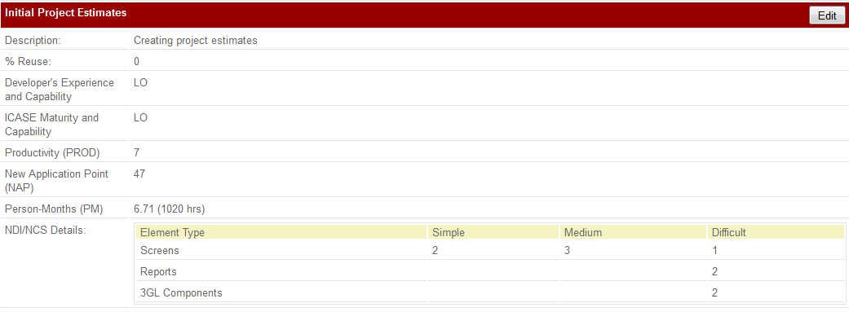
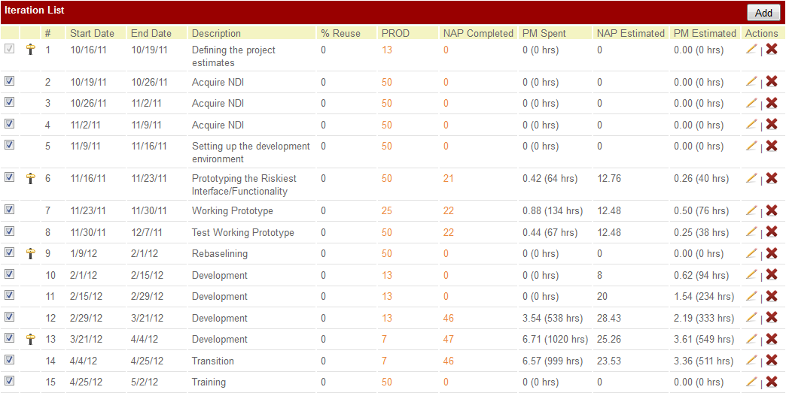
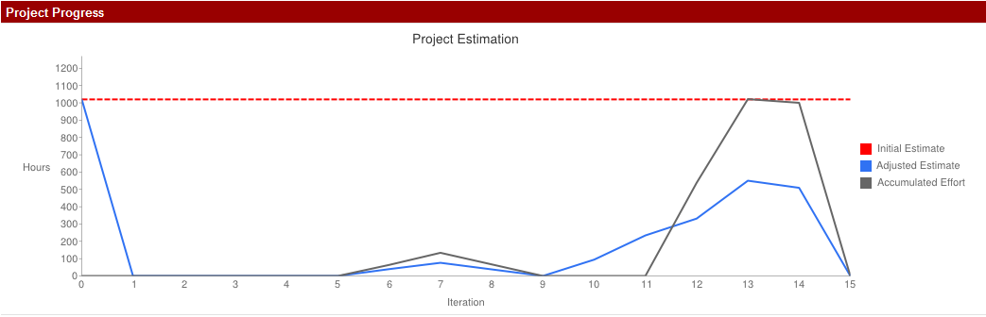
Figure 2 shows Transportation Grant Fund Database project’s rough estimation. Development team is not going to reuse neither of the future components, thus the % Reuse = 0. Developer’s Experience and Capability is estimated as Low, due to the Personnel Factors estimation (ACAP, PCAP, PCON, APEX, PLEX and LTEX) from the Table 12. ICASE Maturity and Capability value is obtained from the TOOL Project Factor (Table 12).Since Developer’s Experience and Capability and ICASE Maturity and Capability values are Low, Productivity (PROD) is 7, a number drawn from Figure 5.1 (COCOMOΙΙ, page 195). New Application Point (NAP) is the sum of all the weighted element instances from the NDI/NCS Details. Person-Month (PM) is computed by the COTIPMO tool using next equations:

PM = NAP / PROD, which is 47/7 ≈6.71 PM.

6.71/1.67 ≈ 3.93, which means that the project is doable with the team of 4 people.
    - Iteration Plan

Plan
There are 3 iterations planned in the Development phase of the Transportation Grant Fund Database project. Estimated dates are as follows:

- Construction iteration 1: 2/1/12-2/28/12
- Construction iteration 2: 2/29/12- 4/2/12
- Transition iteration: 4/3/12- 5/4/12

During the first increment of construction iteration the most important features will be developed, which are “must have” requirements. At the end of this iteration pilot run with system demonstration to the client on the LADOT’s site will be executed. Intermediate feedback forms will be collected from the customers at the end of pilot run.
The second increment of the construction iteration will be developing the remaining “should” and “could have” capabilities, as well as glue coding and debugging already existent functionalities to get ready for the main milestone Core Capability Drive-through.
The transition iteration is accountable for the transition of the executable system to the client’s production server and training of the users, client and maintainers.
Table 13 reflects capabilities that are planned to be implemented.
Table 13: Construction iteration capabilities to be implemented
Functionality ID | Description | Priority | Increment
OC-1 Role-based access control (RBAC) | The system provides the capability of assigning predefined security roles to users | Must have | 1
OC-2 Project coordinators approved user registration | The system provides the capability to the Project coordinator to selectively approve user registration | Must have | 1
OC-3 Electronically storing all project information | The system provides the capability of storing all project information and related attached documents electronically | Must have | 1
OC-4 Attaching documents | The system provides the capability of attaching physical files to the grant fund projects | Must have | 1
OC-5 Report Generation | The system provides the capability of generating reports in easy to print format (Quarterly & progress reports) | Must have | 1
OC-6 Export project data | The system is capable of exporting grant fund projects data into XML standard format | Could Have | 2*
OC-7 Deadlines & notifications | The system provides the capability of setting deadlines for projects and sending reminders before certain due dates by email | Could Have | 2
OC-8 Sending emails | The system provides the functionally of sending emails to the users of the system | Should Have | 2
* this is an evolutionary requirement so it will most likely not be implemented but we are including it in the 2nd iteration in case we have time to look at it.

Table 14 shows functionalities that are to be tested.
Table 14: Construction iteration capabilities to be tested
Functionality ID | Description | Priority | Increment
OC-1 Role-based access control (RBAC) | The system provides the capability of assigning predefined security roles to users | Must have | 1
OC-2 Project coordinators approved user registration | The system provides the capability to the Project coordinator to selectively approve user registration | Must have | 1
OC-3 Electronically storing all project information | The system provides the capability of storing all project information and related attached documents electronically | Must have | 1
OC-4 Attaching documents | The system provides the capability of attaching physical files to the grant fund projects | Must have | 1
OC-5 Report Generation | The system provides the capability of generating reports in easy to print format (Quarterly & progress reports) | Must have | 1
OC-6 Export project data | The system is capable of exporting grant fund projects data into XML standard format | Could Have | 2*
OC-7 Deadlines & notifications | The system provides the capability of setting deadlines for projects and sending reminders before certain due dates by email | Could Have | 2
OC-8 Sending emails | The system provides the functionally of sending emails to the users of the system | Should Have | 2
* this is an evolutionary requirement so it will most likely not be implemented but we are including it in the 2nd iteration in case we have time to look at it

All capabilities listed above will be tested in either first or second construction increments.

Iteration Assessment
Table 15 lists capabilities that are implemented and tested in 2 construction iterations on development server. The system was successfully deployed to LADOT server during the transition iteration, and the capabilities listed below were implemented on production server. Several users training sessions were also provided by development team. Currently, end users testing the system and collecting feedback.
Table 15: Construction iteration capabilities implemented and tested
Functionality ID | Description | % completed | % tested
OC-1 Role-based access control (RBAC) | The system provides the capability of assigning predefined security roles to users | 100 | 100
OC-2 Project coordinators approved user registration | The system provides the capability to the Project coordinator to selectively approve user registration | 100 | 100
OC-3 Electronically storing all project information | The system provides the capability of storing all project information and related attached documents electronically | 100 | 100
OC-4 Attaching documents | The system provides the capability of attaching physical files to the grant fund projects | 100 | 100
OC-5 Report Generation | The system provides the capability of generating reports in easy to print format (Quarterly & progress reports) | 100 | 100
OC-6 Export project data | The system is capable of exporting grant fund projects data into XML standard format | 0 | 0
OC-7 Deadlines & notifications | The system provides the capability of setting deadlines for projects and sending reminders before certain due dates by email | 100 | 100
OC-8 Sending emails | The system provides the functionally of sending emails to the users of the system | 100 | 100

Capabilities Implemented, Tested, and Results
Following are the capabilities that were implemented and test results that were obtained by the end of 2nd iteration.
Table 16: Construction iteration capabilities implemented and tested in 2 iterations
OC | Capability | Test Results | If fail, Why?
OC-1 | Role-based access control (RBAC) | Pass
OC-2 | Project coordinators approved user registration | Pass
OC-3 | Electronically storing all project information | Pass
OC-4 | Attaching documents | Pass
OC-5 | Report Generation | Pass
OC-6 | Export project data | Not tested | Note: It is an evolutionary requirement.
OC-7 | Deadlines & notifications | Pass
OC-8 | Sending emails | Pass

Core Capability Drive-Through Result
The comments team got during the CCD are mostly positive. Although there are some issues that need to be discussed with the end user, such as whether the sponsor in the reports is the same person who signs the report and whether the date submitted and signed should be the same, overall the client was impressed by the already implemented features.
Also there were medium and low priority improvements and suggestions made:

- Sign in problem – system asks to reenter login credentials when user signs in for several times. To properly Sign out and then sign in user should close the browser which was impossible during the CCD, since the connection to the LADOT intranet was through the VPN. Needs to be tested within the LADOT intranet.
- End user should know in advance which type of the report (MOU or LOA) he/she wants to generate.
- Use a drop down menu to choose a Fiscal year and Quarter.
- Add ‘%’ sign in the end of the field, so that users would know that the value entered is the percentage.
- 2B question’s answers should not be changed once filled out, or changed only via editing the project’s attributes.
- 2C misspell ‘month’, should be plural.
- For the fields that are date put a date picker (calendar).
- Put space or a line between question and narrative.
- Pop a confirmation dialog when submit, close.
- The calculations in the MOU tables should be done by entering only one number (Expenditures total).
- Some tables are cut in the PDF, so the alignment should be fixed.

For the rest of the project the highest priority is to fix all bugs that were reported for the core capabilities (OC 1 – OC 5), then is to develop and test ‘could and should have’ capabilities, which are OC 7 and 8, and finally if the time permits to implement an evolutionary requirement (OC 6). Since the client refused to have any kind (paper or video) of user manuals, the development team will focus on making the UI more intuitive.

There are more than several risks that were mitigated from the last ARB, here are some of them:
• Convert to PDF – Muhimbi PDF Converter was purchased by LADOT
• The licensing issues for the trial software were solved.
• Team’s unfamiliarity with the PM Central was also mitigated.
And here are some risks that were introduced:
• Problems with the testers’ VPN access.
• User fails to log out while connected through VPN.
• Making UI more intuitive.

Adherence to Plan
All requirements are implemented and successfully delivered to the client. Thus, the development team is on schedule and following the plan.

